Ilan Weinschelbaum

COMP260 HW2

1) 

2) 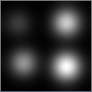

3) sigma=2 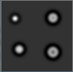

Sigma=6 

We can see that sigma=2 gives a much sharper-looking image. This makes sense since smaller standard deviation means that the program will be more easily able to find differences in shade. This is because, with lower standard deviation, each extreme difference is more standard deviations from the mean, making the image crisper.

5) 